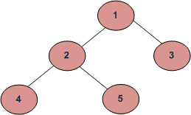null null

Null Null null null

In Order Traversal - Left Root Right (for each node recursively) - 4, 2, 5, 1, 3

Pre Order Traversal - Root Left Right (For each node recursively) - 1, 2, 4, 5, 3

Post Order Traversal - Left Right Root (For Each Node Recursively) - 4, 5, 2, 3, 1

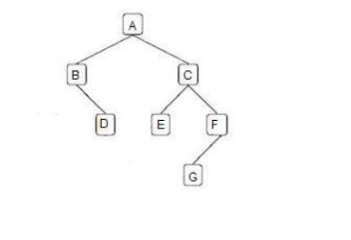

Inorder – left root right B, D, A, E, C, G, F

Preorder – root left right

Postorder – left right root

INFIX TO POSTFIX

( A * (B + C / D ) – E / F)

|  |  |  |
| --- | --- | --- |
| CHARACTER | STACK | POSTFIX EXPRESSION |
| ( | ( |  |
| A | ( | A |
| * | (* | A |
| ( | (*( | A |
| B | (*( | AB |
| + | (*(+ | AB |
| C | (*(+ | ABC |
| / | (*(+/ | ABC |
| D | (*(+/ | ABCD |
| ) | (* | ABCD/+ |
| - | (- | ABCD/+* |
| E | (- | ABCD/+*E |
| / | (-/ | ABCD/+*E |
| F | (-/ | ABCD/+*EF |
| ) | empty | ABCD/+*EF/- |

(P * Q / R + ( S + T))

|  |  |  |
| --- | --- | --- |
| CHARACTER | STACK | POSTFIX |
| ( | ( |  |
| P | ( | P |
| * | (* | P |
| Q | (* | PQ |
| / | (/ | PQ* |
| R | (/ | PQ*R |
| + | (+ | PQ*R/ |
| ( | (+( | PQ*R/ |
| S | (+( | PQ*R/S |
| + | (+(+ | PQ*R/S |
| T | (+(+ | PQ*R/ST |
| ) | (+ | PQ*R/ST+ |
| ) | EMPTY | PQ*R/ST++ |
|  |  |  |

(A+(B-C*(D/E)*F)) A(B((C(DE/)*)F*)-)+

|  |  |  |
| --- | --- | --- |
| CHARACTER | STACK | POSTFIX |
| ( | ( |  |
| A | ( | A |
| + | (+ | A |
| ( | (+( | A |
| B | (+( | AB |
| - | (+(- | AB |
| C | (+(- | ABC |
| * | (+(-* | ABC |
| ( | (+(-*( | ABC |
| D | (+(-*( | ABCD |
| / | (+(-*(/ | ABCD |
| E | (+(-*(/ | ABCDE |
| ) | (+(-* | ABCDE/ |
| * | (+(-* | ABCDE/* |
| F | (+(-* | ABCDE/*F |
| ) | (+ | ABCDE/*F*- |
| ) | EMPTY | ABCDE/*F*-+ |

((A+B*C) – (E*F/H) + J) ABC*+EF*H/-J+

|  |  |  |
| --- | --- | --- |
| CHARACTER | STACK | POSTFIX |
| ( | ( |  |
| ( | (( |  |
| A | (( | A |
| + | ((+ | A |
| B | ((+ | AB |
| * | ((+* | AB |
| C | ((+* | ABC |
| ) | ( | ABC*+ |
| - | (- | ABC*+ |
| ( | (-( | ABC*+ |
| E | (-( | ABC*+E |
| * | (-(* | ABC*+E |
| F | (-(* | ABC*+EF |
| / | (-(/ | ABC*+EF* |
| H | (-(/ | ABC*+EF*H |
| ) | (- | ABC*+EF*H/ |
| + | (+ | ABC*+EF*H/- |
| J | (+ | ABC*+EF*H/-J |
| ) | EMPTY | ABC*+EF*H/-J+ |
|  |  |  |
|  |  |  |
|  |  |  |

INFIX - (A+B/C * (D/E*F)) POSTFIX - ABC/DE/F**+ PREFIX - +A*/BC*/DEF

|  |  |  |
| --- | --- | --- |
| CHARACTER | STACK | POSTFIX |
| ( | ( |  |
| A | ( | A |
| + | (+ | A |
| B | (+ | AB |
| / | (+/ | AB |
| C | (+/ | ABC |
| * | (+* | ABC/ |
| ( | (+*( | ABC/ |
| D | (+*( | ABC/D |
| / | (+*(/ | ABC/D |
| E | (+*(/ | ABC/DE |
| * | (+*(* | ABC/DE/ |
| F | (+*(* | ABC/DE/F |
| ) | (+* | ABC/DE/F* |
| ) | EMPTY | ABC/DE/F**+ |

INFIX - (A+B/C * (D/E*F)) ((F*E/D) * C/B+A)

|  |  |  |
| --- | --- | --- |
| CHARACTER | STACK | POSTFIX |
| ( | ( |  |
| ( | (( |  |
| F | (( | F |
| * | ((* | F |
| E | ((* | FE |
| / | ((*/ | FE |
| D | ((*/ | FED |
| ) | ( | FED/* |
| * | (* | FED/* |
| C | (* | FED/*C |
| / | (*/ | FED/*C |
| B | (*/ | FED/*CB |
| + | (+ | FED/*CB/* |
| A | (+ | FED/*CB/*A |
| ) | EMPTY | FED/*CB/*A+ |

FED/*CB/*A+ -> +A*/BC*/DEF +A*/BC*/DEF

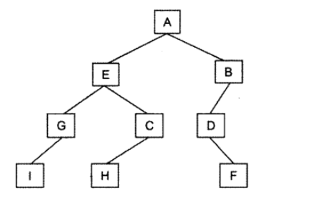

In order – left root right – I, G, E, H, C, A, D, F, B

Pre Order – Root left right – A, E, G, I, C, H, B, D, F

Post Order – Left Right Root – I, G, H, C, E, F, D, B, A

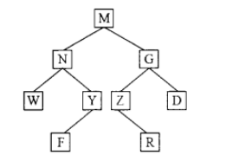

Post order - left right root – W, F, Y, N, R, Z,D,G,M

Pre order – root left right – M, N, W, Y, F, G, Z, R, D

In order – Left root right – W, N , F, Y, M, Z, R, G, D

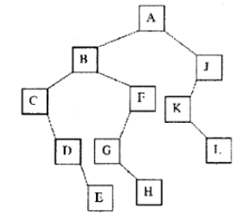

Post order – Left right root – E,D,C,H,G, F, B, L, K, J, A

Pre Order – Root left right – A, B, C, D, E, F, G, H, J, K, L

In Order – C, D, E., B , G, H, F, A, K, L, J

23, 37, 11, 69, 42, 45, 30, 98, 91

|  |  |  |  |  |  |  |  |  |  |  |  |  |
| --- | --- | --- | --- | --- | --- | --- | --- | --- | --- | --- | --- | --- |
|  |  |  |  | 23 |  |  |  |  |  |  |  |  |
|  |  |  | 11 |  | 37 |  |  |  |  |  |  |  |
|  |  |  |  | 30 |  | 69 |  |  |  |  |  |  |
|  |  |  |  |  | 42 |  |  | 98 |  |  |  |  |
|  |  |  |  |  |  | 45 |  |  |  |  |  |  |
|  |  |  |  |  |  |  | 91 |  |  |  |  |  |
|  |  |  |  |  |  |  |  |  |  |  |  |  |
|  |  |  |  |  |  |  |  |  |  |  |  |  |